Day #1 – What is a government contract

Welcome to Day #1 of 'Govcon for Dummies' training program.

Today we are going to look at defining what exactly is a government contract. There are many types of government contracts but we here at Scorecontracts focus on a specific type where we can identify opportunities to earn real dollars.

We than dive a step further and look at the types of things that the government buys - offering practical examples and visuals to help you realize the size, scope and scale of the marketplace.

You can watch today’s training and get your assignment right here:

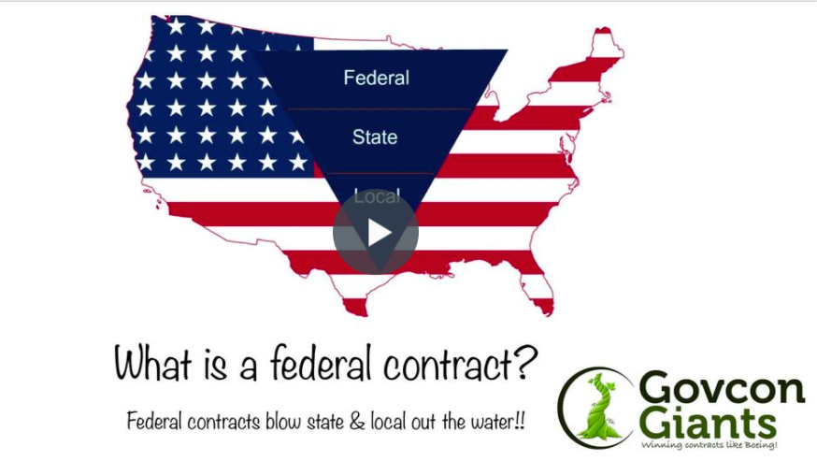

Start Day #1 Right Now!

P.S. I can’t wait for Day #2 training we have a cool animation video that will walk you through what it’s like to win a government contract.

Eric Coffie

